***HTML DOM***

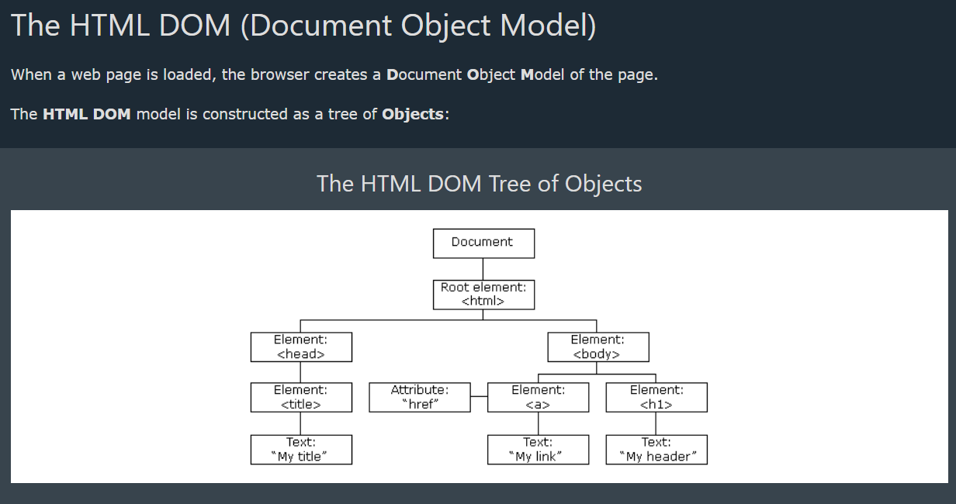

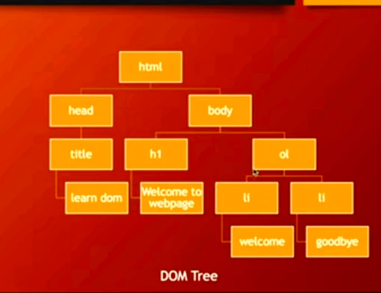



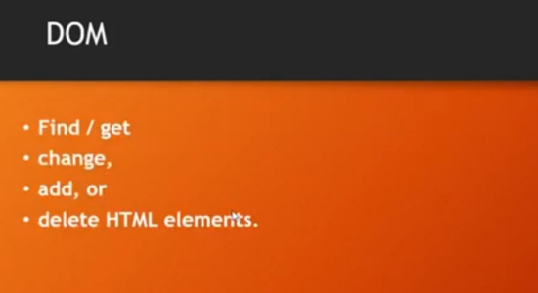



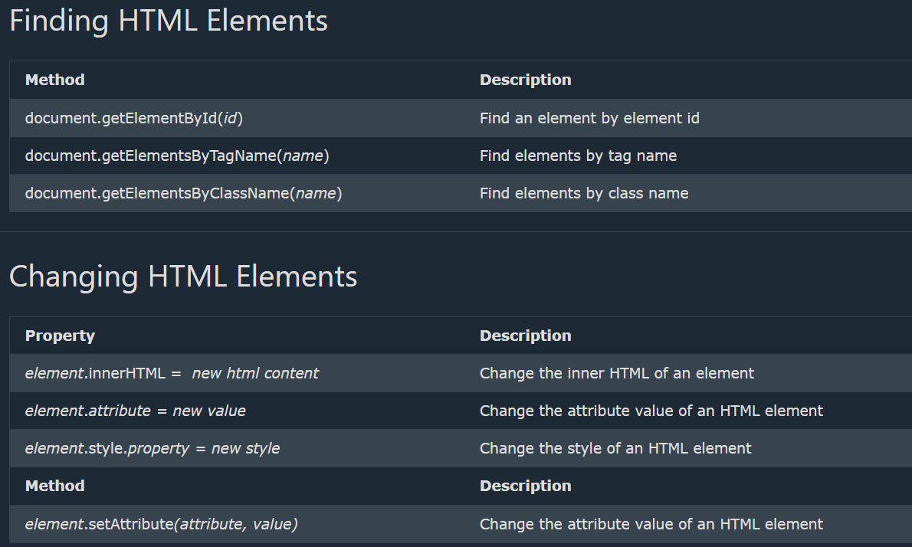





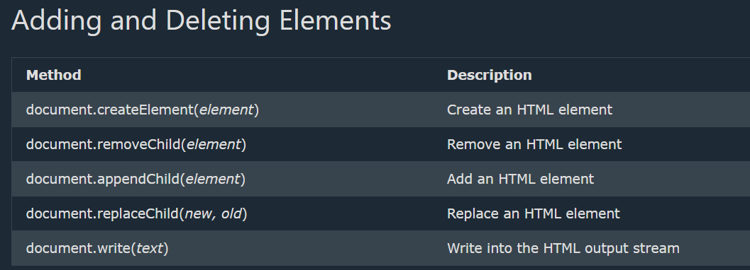

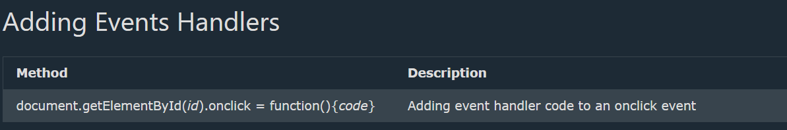

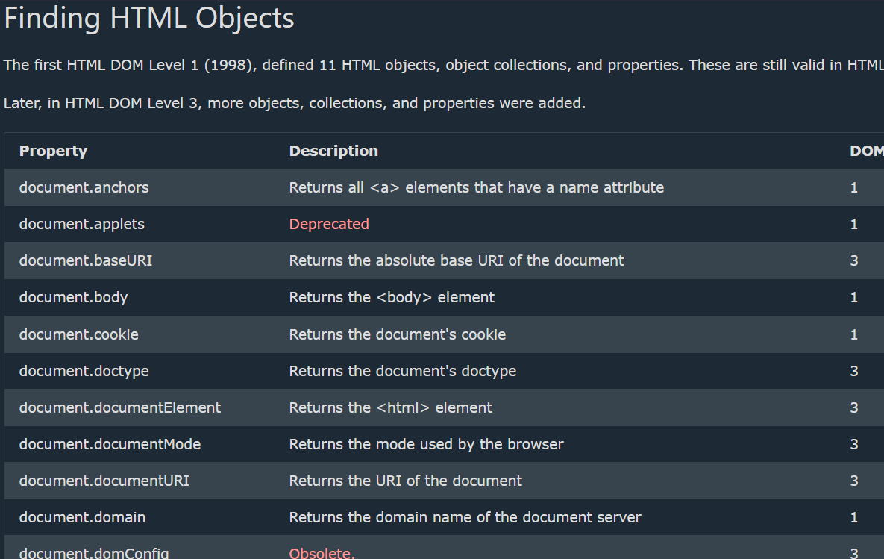

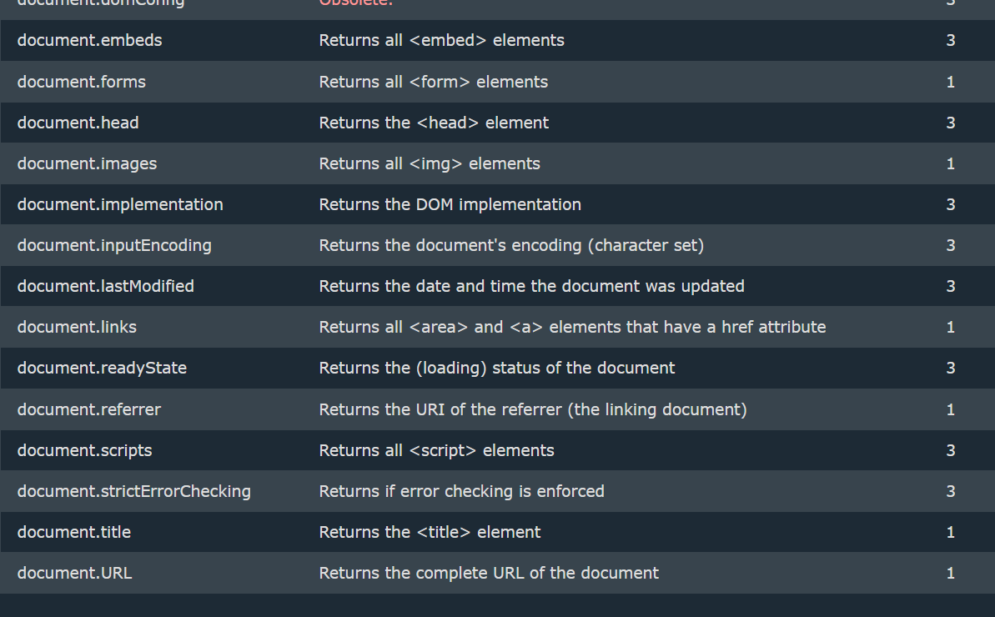

***Finding HTML Elements***

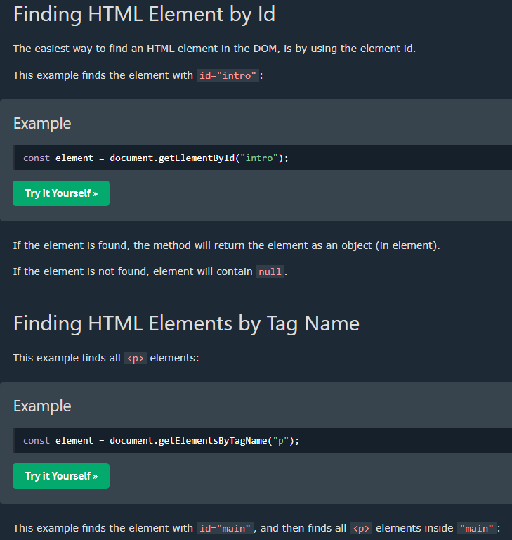

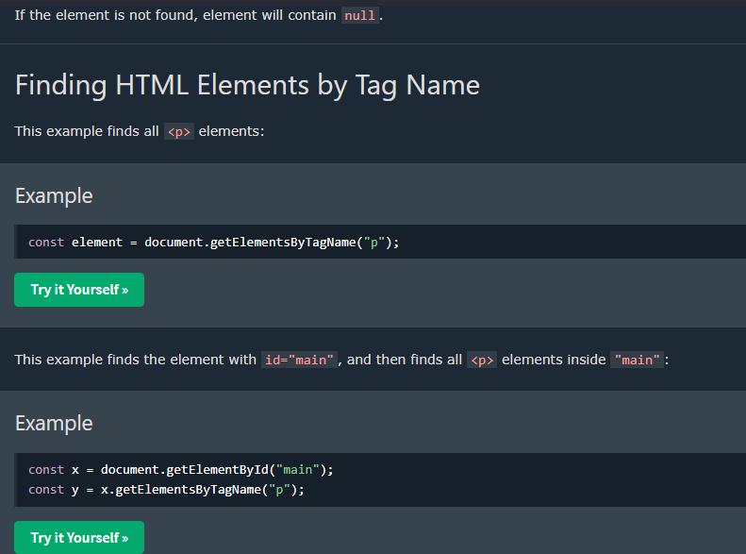

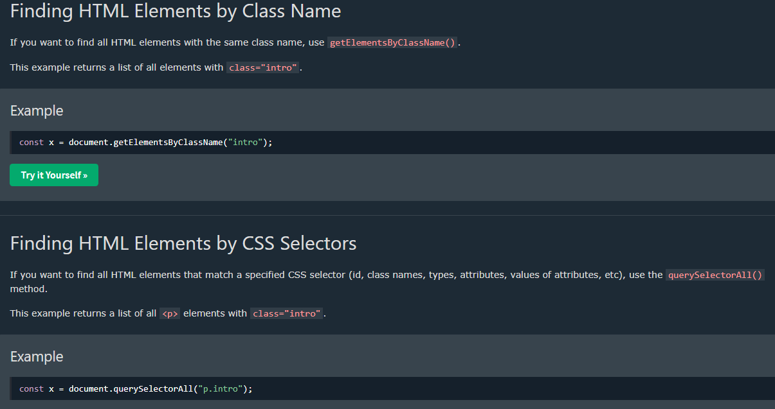

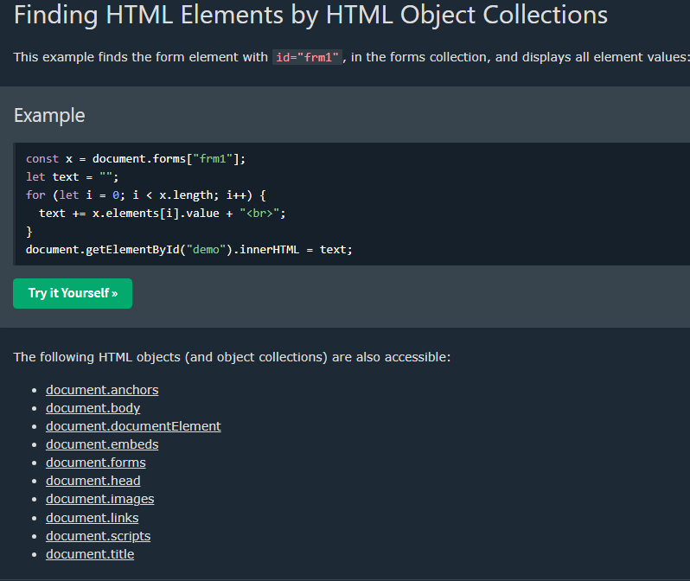

[1_FIND_HTML_ELEMENTS](https://github.com/anisul-Islam/javascript-tutorials-code/tree/master/3_JS%20HTML%20DOM/1_FIND_HTML_ELEMENTS)

**index.html**

<!DOCTYPE html>

<html lang="en">

<head>

<meta charset="UTF-8">

<meta name="viewport" content="width=device-width, initial-scale=1.0">

<title>Document</title>

</head>

<body>

<h1>This is h1</h1>

<h2 id="heading2">This is h2</h2>

<p class="para">This is a paragraph1</p>

<p class="para">This is a paragraph2</p>

<a href="#">Visit Google</a>

<div id="first-div">

<h4>I am h4</h4>

</div>

<div class="my-div">

<ol>

<li>I am a list</li>

</ol>

</div>

<script src="./program27.js"></script>

</body>

</html>

**program27.js**

// DOM -> Document Object Model

// Using DOM We can Find / get, change, add, or delete HTML elements.

// How to find HTML Elements

// document.getElementById()

// document.getElementsByTagName()

// document.getElementsByClassName()

// document.querySelector()

// finding element by ID

var h2 = document.getElementById("heading2");

console.log(h2)

// finding element by tagName

var h1 = document.getElementsByTagName("h1")[0];

console.log(h1)

// finding element by tagName

var p = document.getElementsByClassName("para")[0];

console.log(p)

// finding element by querySelector

var q1 = document.querySelector("#heading2");

console.log(q1)

//it will get the first element of the h1 elements

var q2 = document.querySelector("h1");

console.log(q2)

//it will get the first element of the para class

var q3 = document.querySelector(".para");

console.log(q3)

var list = document.querySelector(".my-div li");

console.log(list)

// finding element by querySelectorAll

var q4 = document.querySelectorAll(".para");

console.log(q4)

***Changing HTML Content***

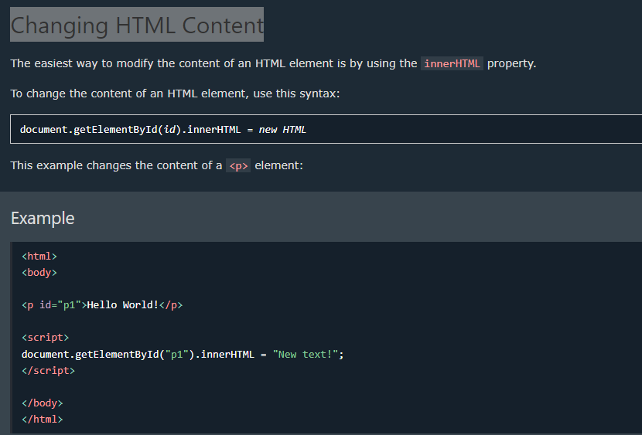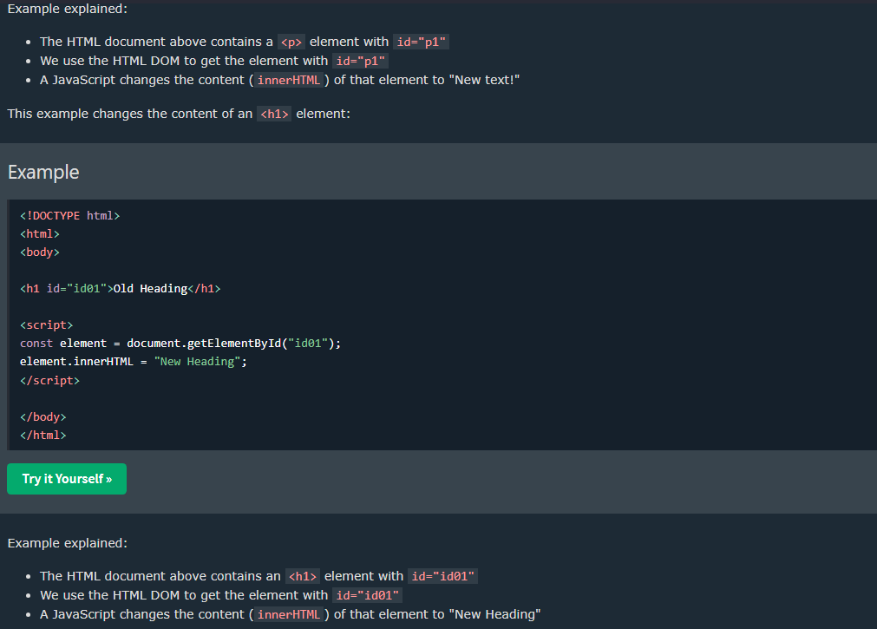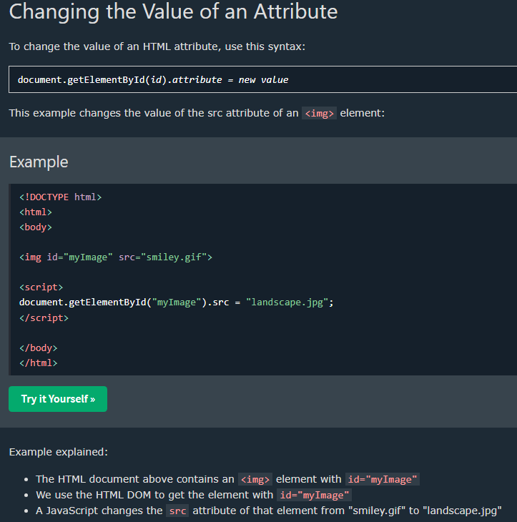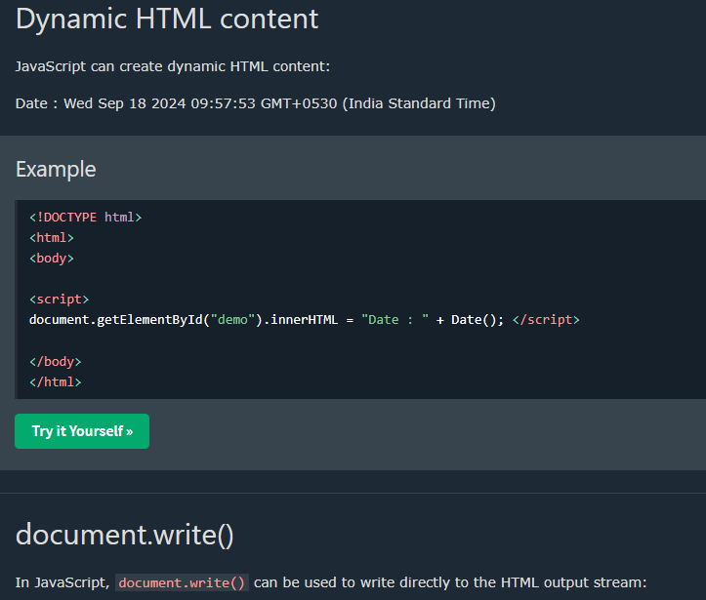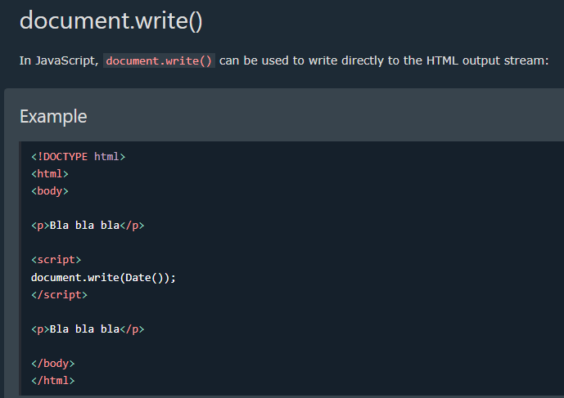**Never use document.write() after the document is loaded. It will overwrite the document.

[2_CHANGE_HTML_ELEMENTS](https://github.com/anisul-Islam/javascript-tutorials-code/tree/master/3_JS%20HTML%20DOM/2_CHANGE_HTML_ELEMENTS)

**index.htm**

<!DOCTYPE html>

<html lang="en">

<head>

<meta charset="UTF-8">

<meta name="viewport" content="width=device-width, initial-scale=1.0">

<title>change html elements</title>

</head>

<body>

<h1>This is h1</h1>

<h2 id="heading2">This is h2</h2>

<p class="para">This is a paragraph1</p>

<p class="para">This is a paragraph2</p>

<a href="#">Visit Google</a>

<div id="first-div">

<h4>I am h4</h4>

</div>

<div class="my-div">

<ol>

<li>I am a list</li>

</ol>

</div>

<script src="./program28.js"></script>

</body>

</html>

**program28.js**

// How to change HTML Elements (collected from W3School website)

// element.innerHTML = new html content -> Change the inner HTML of an element

// element.attribute = new value -> Change the attribute value of an HTML element

// element.style.property = new style -> Change the style of an HTML element

// finding element by ID

var h2 = document.getElementById("heading2");

// changing elements text, id

h2.innerHTML = "I love Bangladesh";

h2.id = "heading2-new";

console.log(h2);

var a = document.querySelector("a");

console.log(a)

a.textContent="visit my website";

a.href="http://www.studywithanis.com"

// changing style of element

a.style.textDecoration = "none";

a.style.color = "green";

a.style.fontSize = "2rem";

[3_CREATE_ADD_REMOVE_HTML_ELEMENTS](https://github.com/anisul-Islam/javascript-tutorials-code/tree/master/3_JS%20HTML%20DOM/3_CREATE_ADD_REMOVE_HTML_ELEMENTS)

**index.html**

<!DOCTYPE html>

<html lang="en">

<head>

<meta charset="UTF-8">

<meta name="viewport" content="width=device-width, initial-scale=1.0">

<title>Document</title>

</head>

<body>

<h1>This is h1</h1>

<h2 id="heading2">This is h2</h2>

<p class="para">This is a paragraph1</p>

<p class="para">This is a paragraph2</p>

<a href="#">Visit Google</a>

<div id="first-div">

<h4>I am h4</h4>

</div>

<div class="my-div">

<ol>

<li>I am a list</li>

</ol>

</div>

<script src="./index.js"></script>

</body>

</html>

**index.js**

//Create, remove, add html element

// creating html element and adding to a div

var firstDiv = document.querySelector("#first-div");

console.log(firstDiv)

var heading3 = document.createElement("h3");

var text = document.createTextNode("This is heading 3");

heading3.appendChild(text);

firstDiv.appendChild(heading3);

var heading5 = document.createElement("h5");

var text = document.createTextNode("This is heading 5");

heading5.appendChild(text);

firstDiv.appendChild(heading5);

// remove element

firstDiv.removeChild(heading5);

//adding element before

var heading6 = document.createElement("h6");

var text = document.createTextNode("This is heading 6");

heading6.appendChild(text);

firstDiv.insertBefore(heading6, heading3);

// firstDiv.insertAfter(heading6, heading3);

[4_CSS_STYLING](https://github.com/anisul-Islam/javascript-tutorials-code/tree/master/3_JS%20HTML%20DOM/4_CSS_STYLING)

**style.css**

.heading-style{

color: green;

font-size: 3rem;

font-weight: bold;

font-style: italic;

}

**index.html**

<!DOCTYPE html>

<html lang="en">

<head>

<meta charset="UTF-8">

<meta name="viewport" content="width=device-width, initial-scale=1.0">

<title>Document</title>

<link rel="stylesheet" href="./style.css">

</head>

<body>

<h1>This is h1</h1>

<h2 id="heading2">This is h2</h2>

<p class="para">This is a paragraph1</p>

<p class="para">This is a paragraph2</p>

<a href="#">Visit Google</a>

<div id="first-div">

<h4>I am h4</h4>

</div>

<div class="my-div">

<ol>

<li>I am a list</li>

</ol>

</div>

<script src="./index.js"></script>

</body>

</html>

**index.js**

// Adding & removing css style in js

var h1 = document.querySelector("h1");

h1.innerHTML = "hiiii"

console.log(h1)

//add css style

h1.classList.add('heading-style')

//removing css style

// h1.classList.remove('heading-style')

*DOM Event*

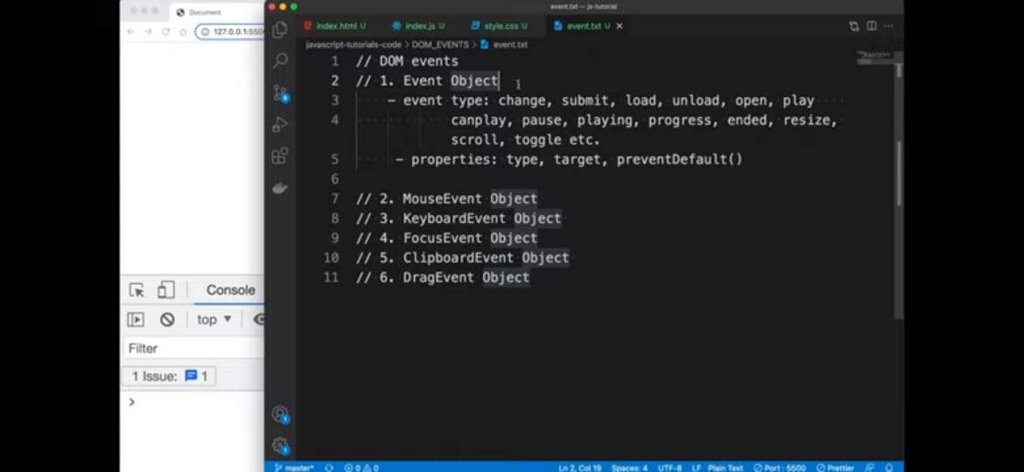

*Click Event*

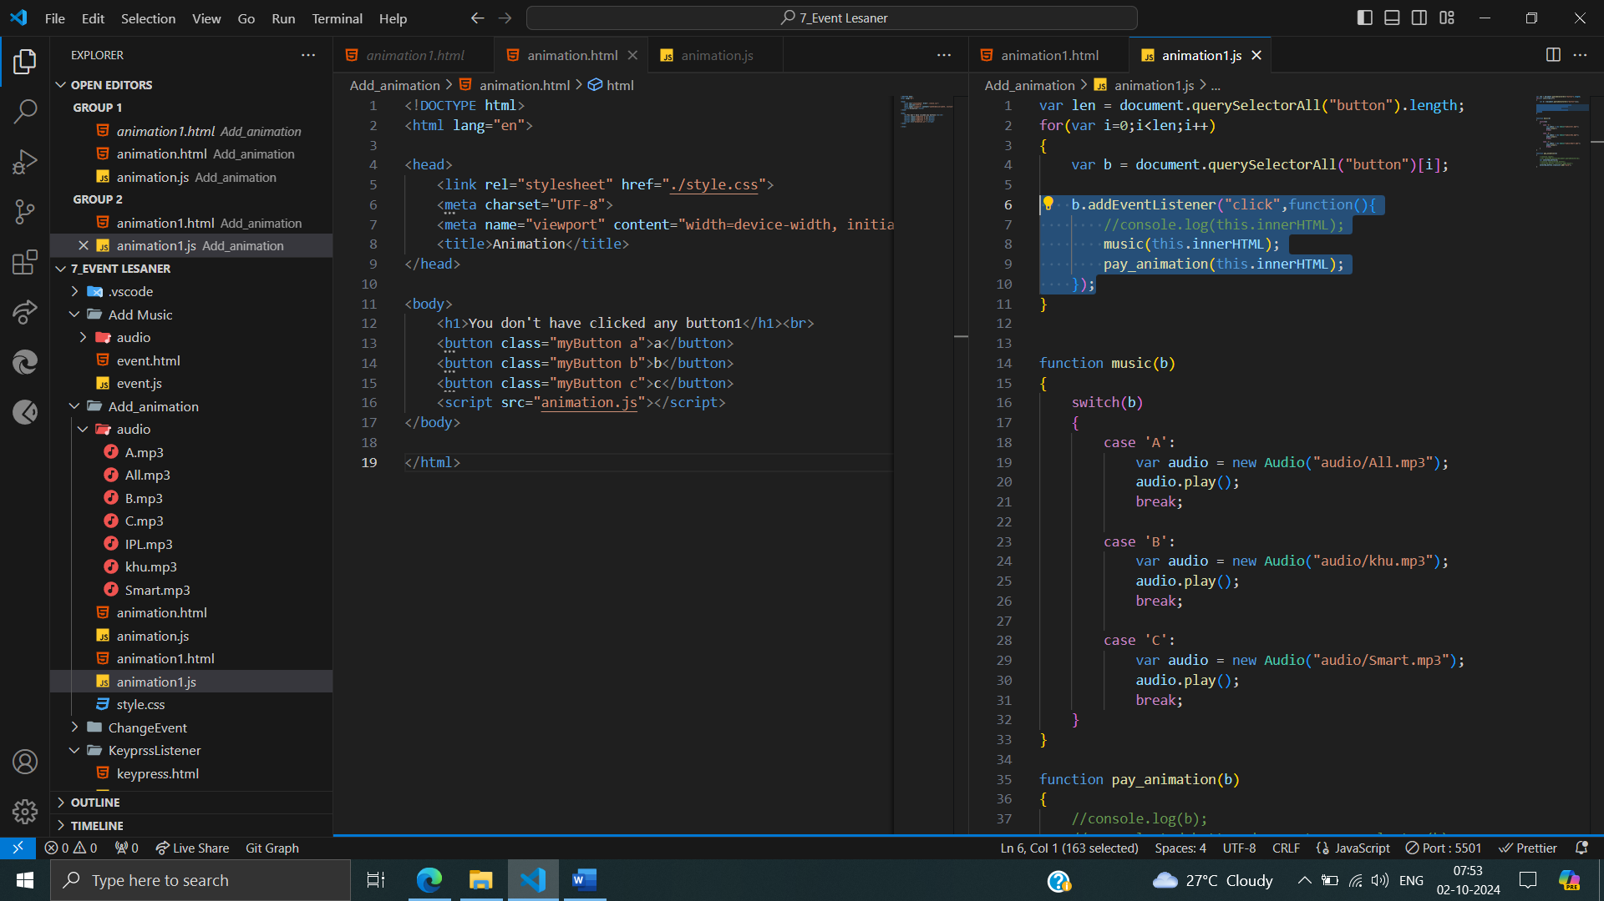

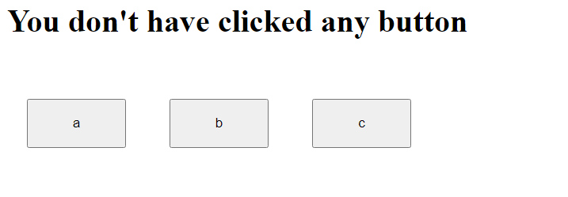

After called click event:

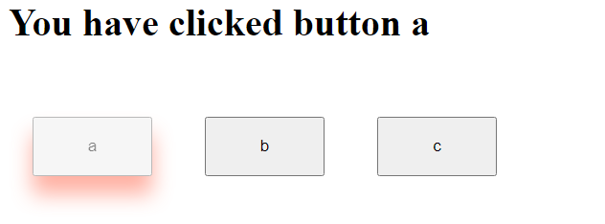

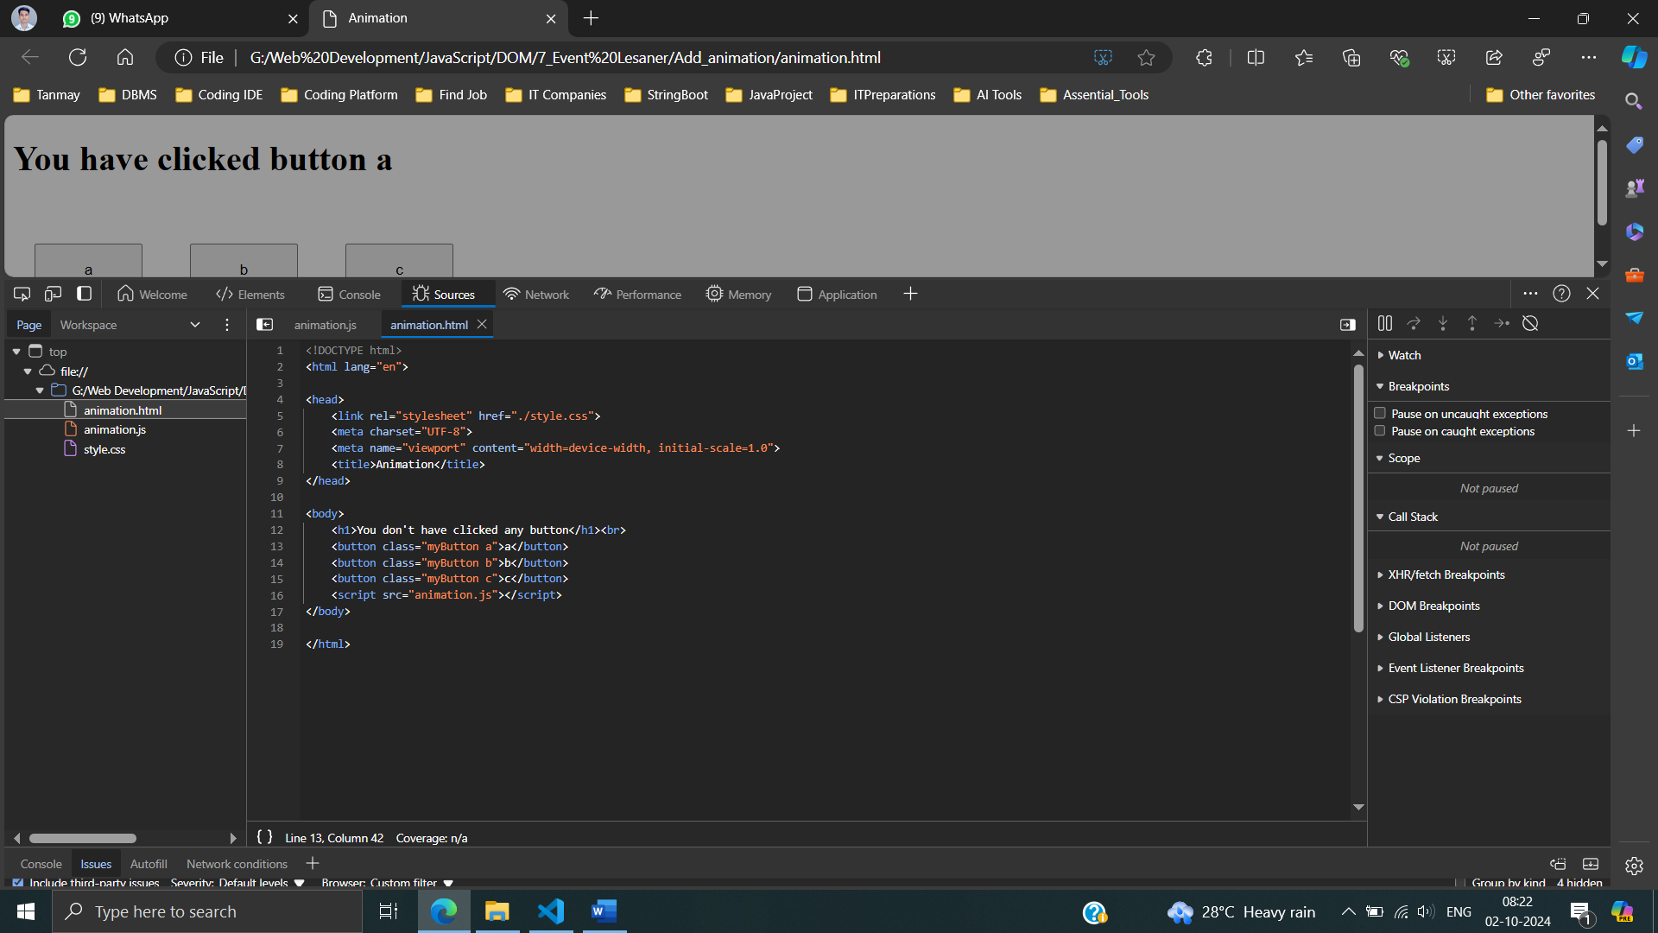

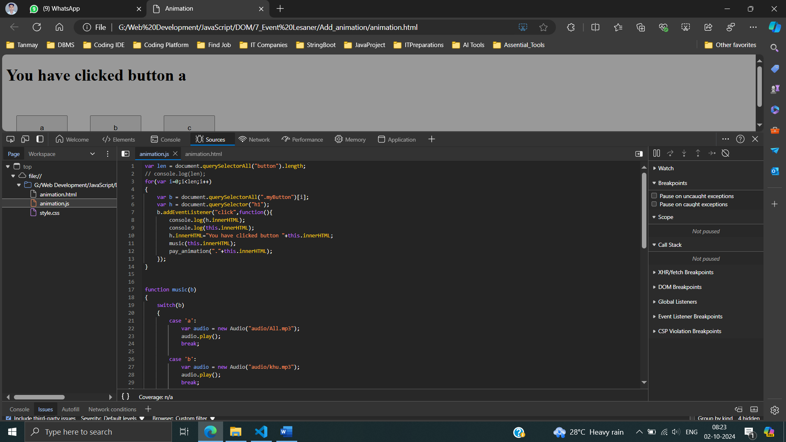 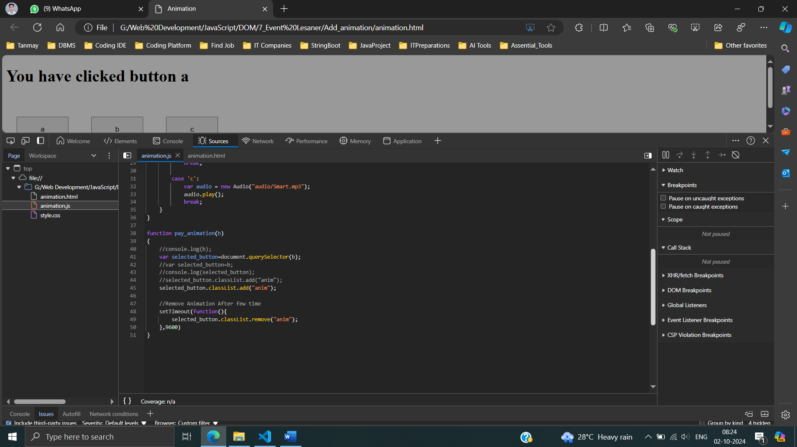

**Keypress Listener :**

keypress events, processes the key information, and triggers corresponding actions (sound and animation) based on the pressed key.



After called click event:



keypressListenerOnButton1.html

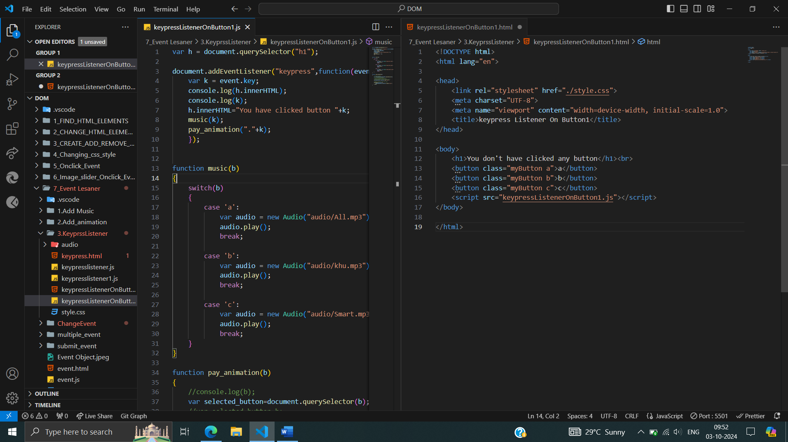

keypressListenerOnButton1.js

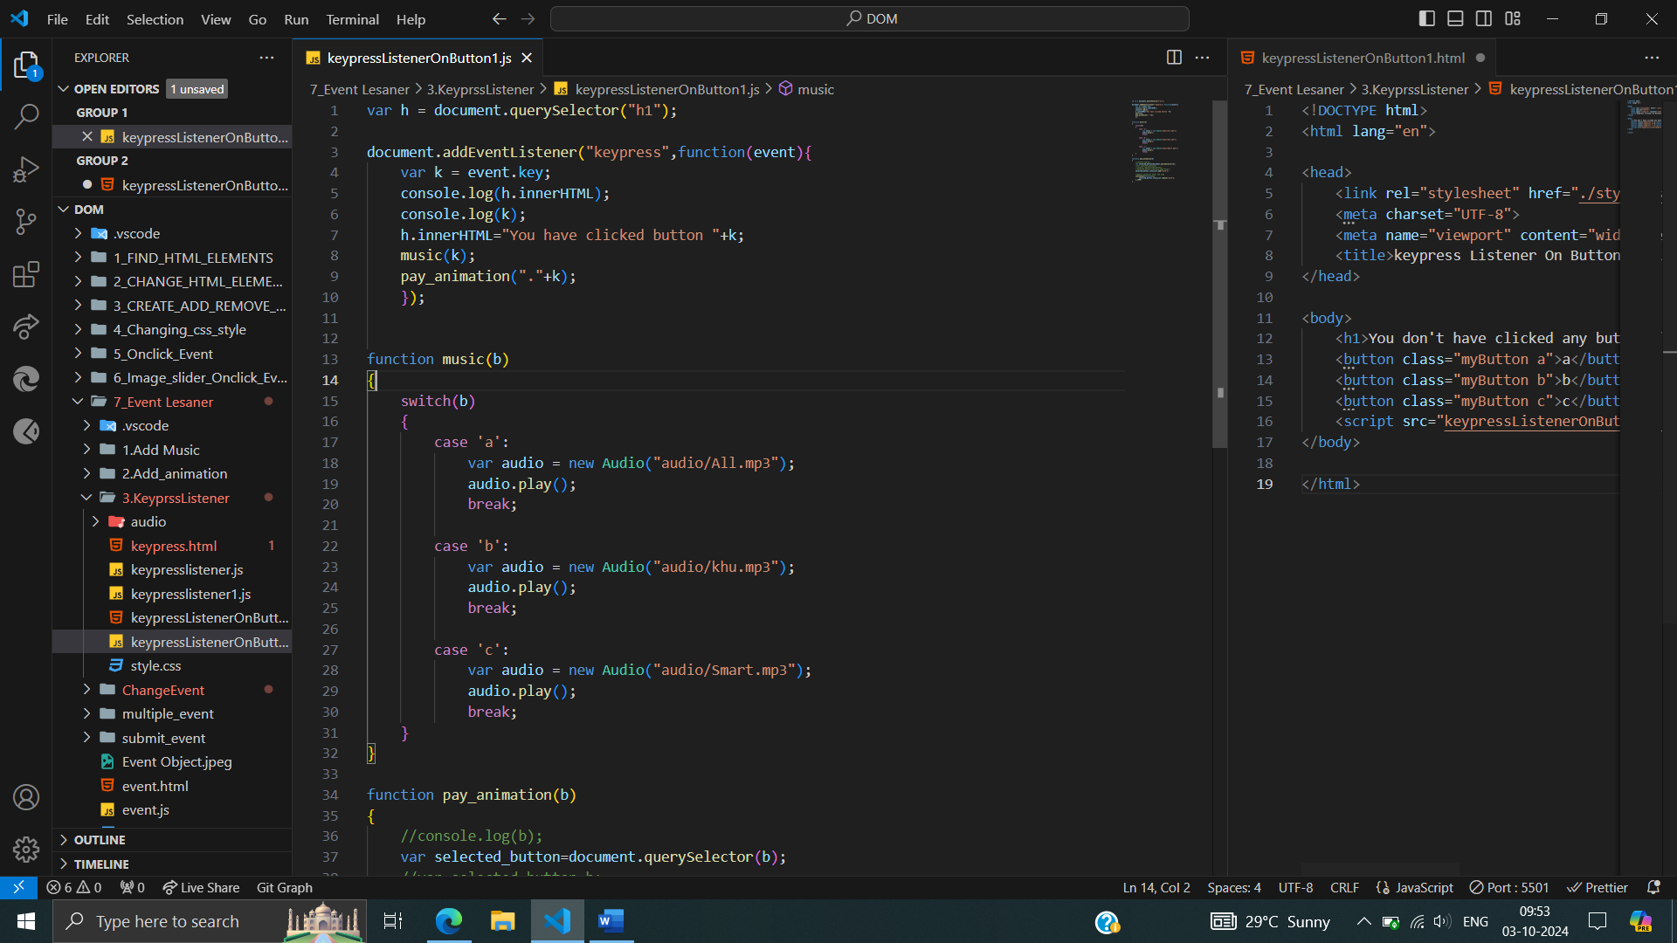

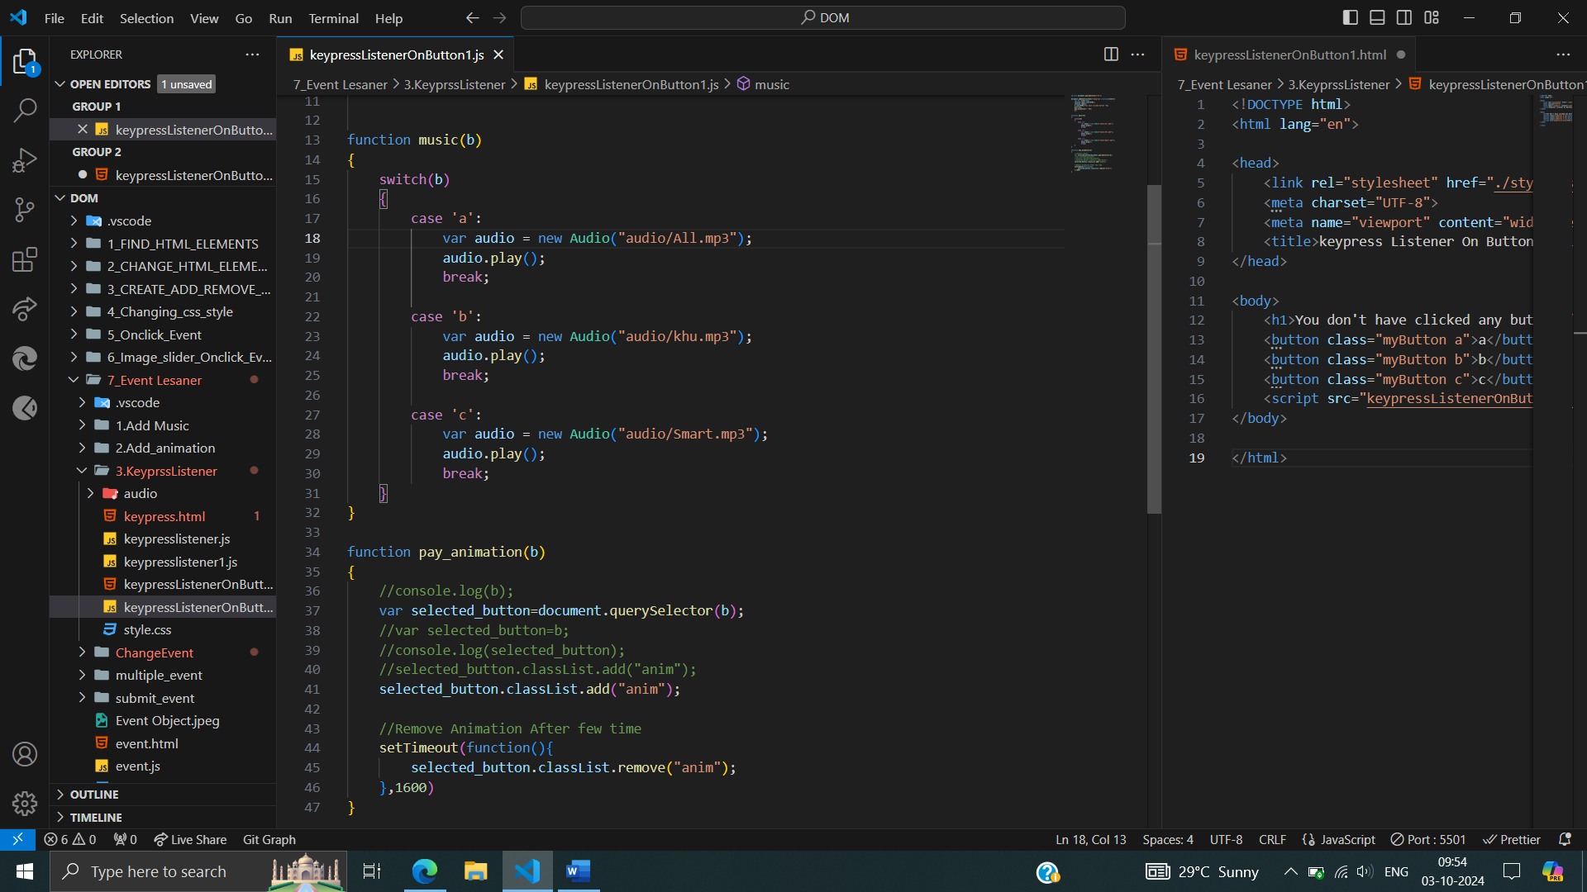

**\* *Dynamically Updating Heading Content Based on Keypresses:***

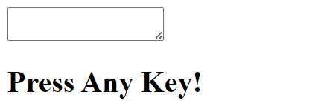

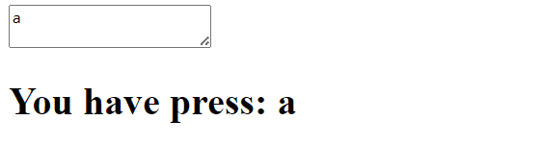

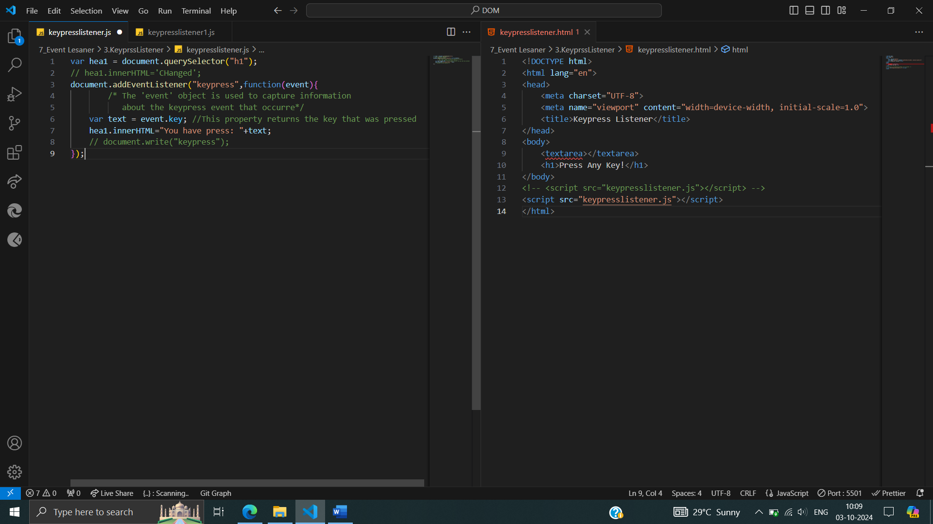



**\*\*Counting No. characters pressed in text area**

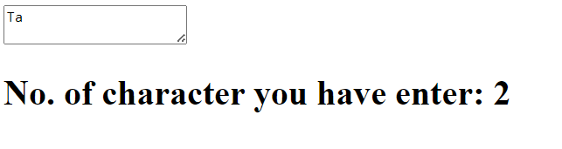

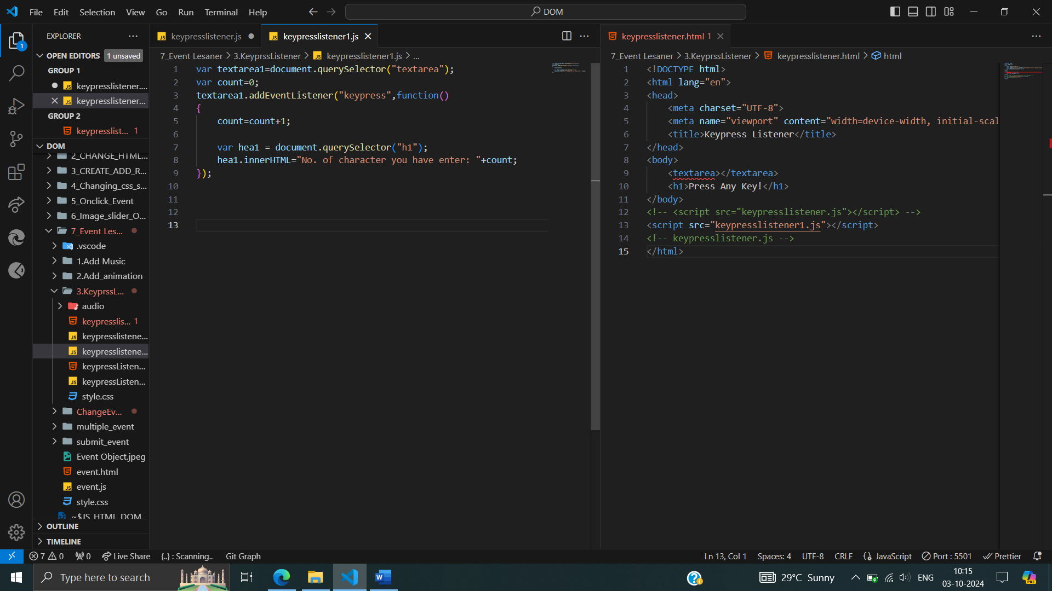

**Change Even Listener :**

The value “Tanmay Samanta” entered into an input field (presumably with a name attribute of "name") whenever the value changes. When the user types in the input field and then either moves focus to a different element or submits the form (depending on browser behavior), the changeHandler function logs the updated value to the console.

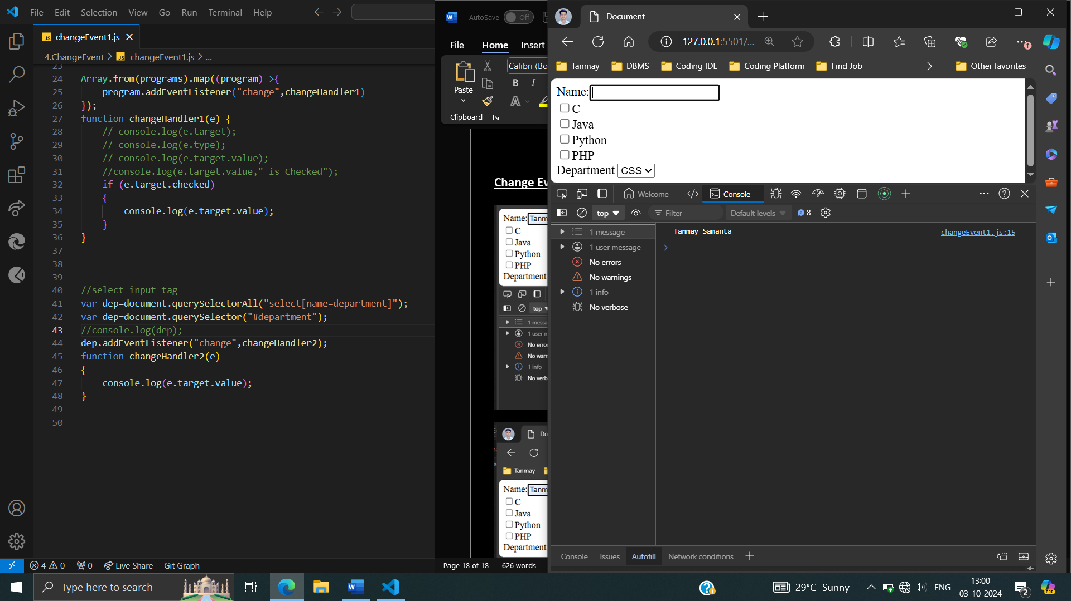 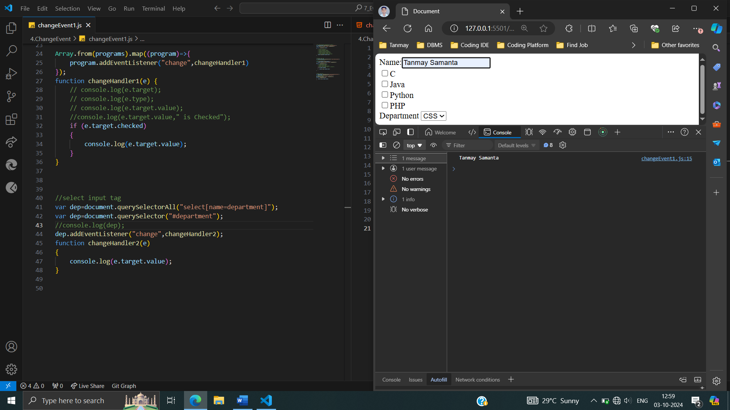

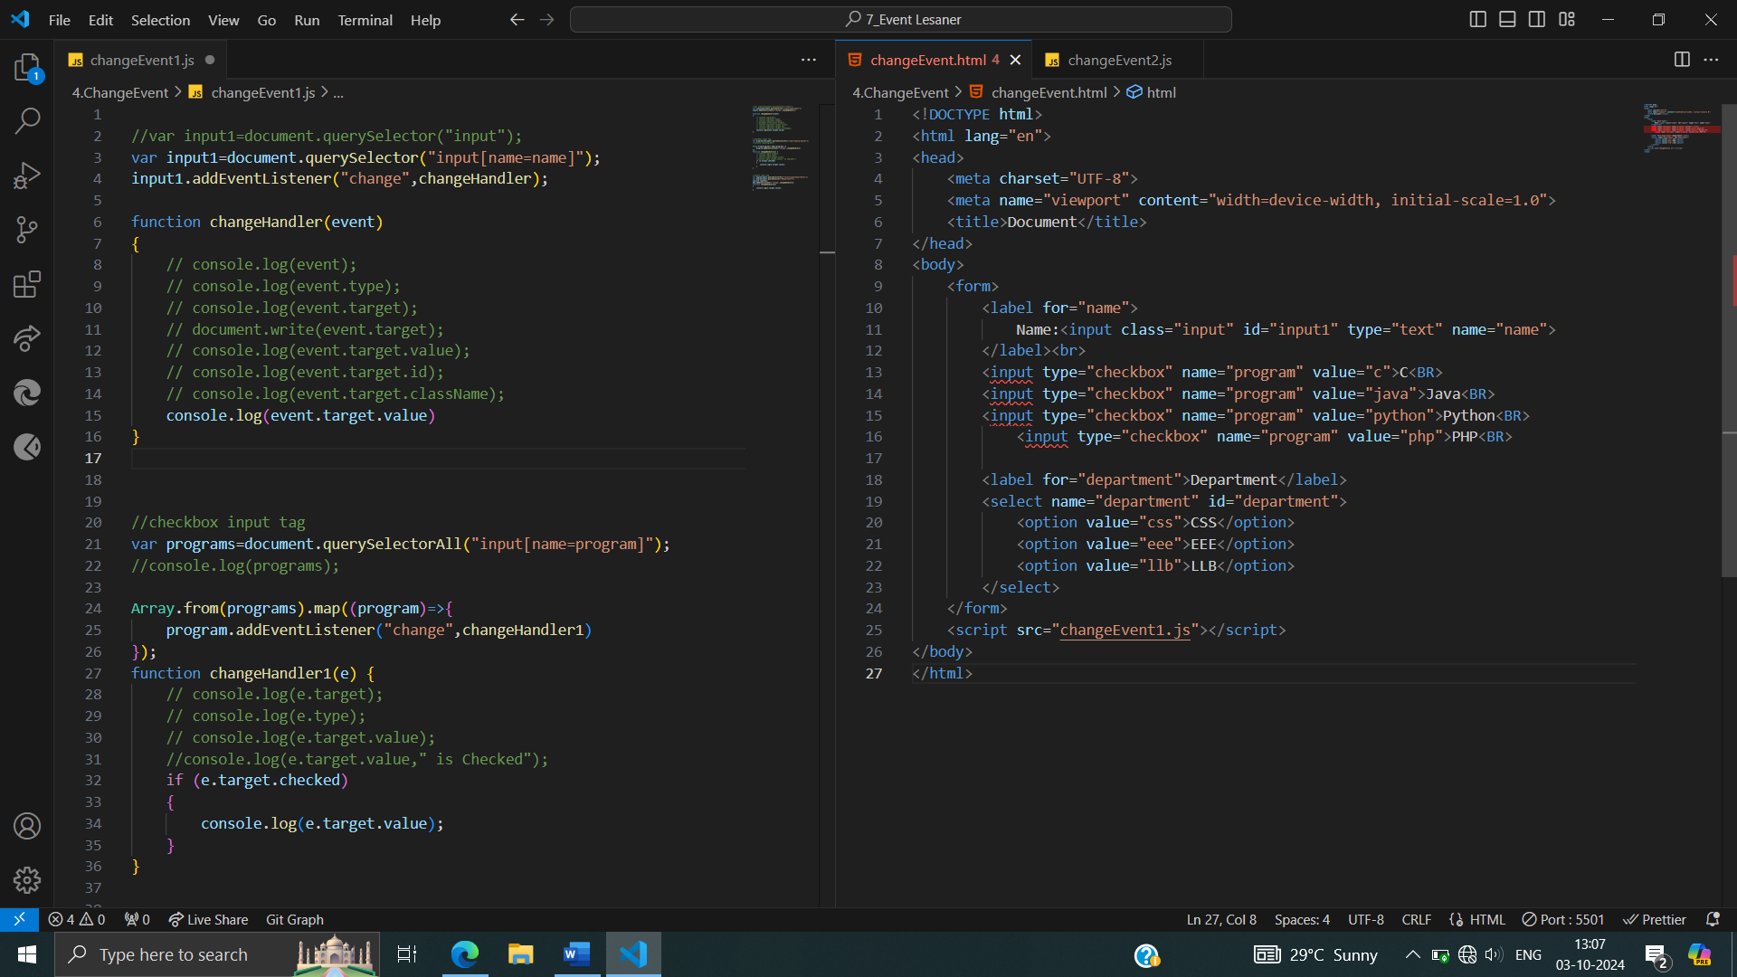

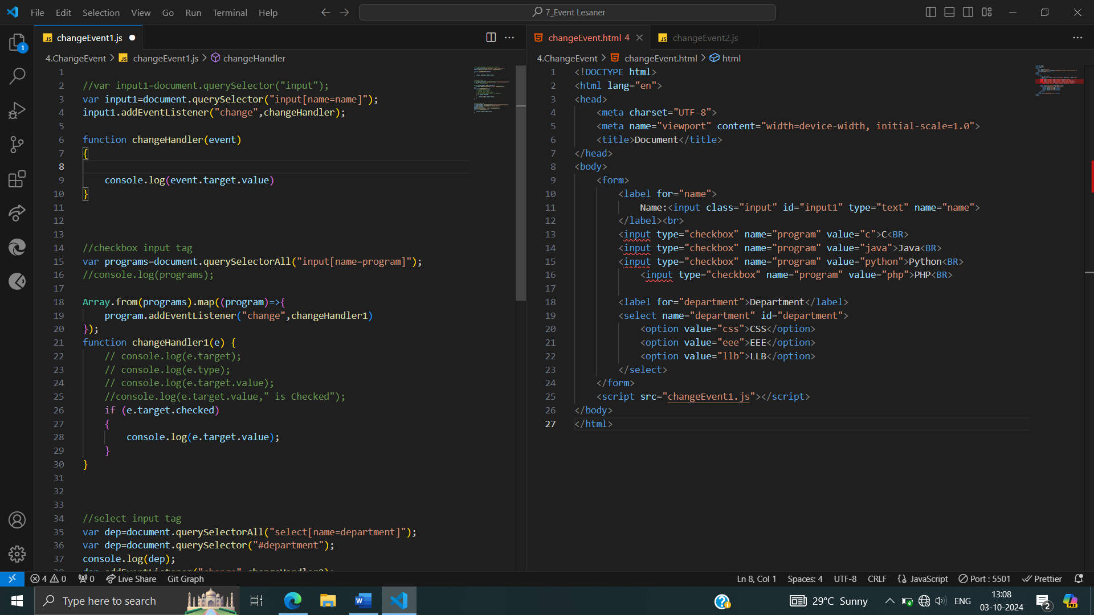

**Event Listeners for Checkboxes:**

Dynamic Checkbox Handling or Capturing Checkbox Changes.

Listens for checkbox changes and logs their values when checked, providing a mechanism to track user selections.

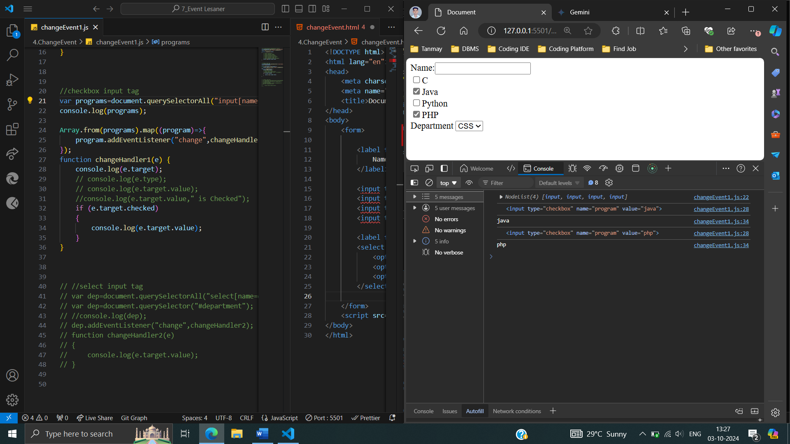

 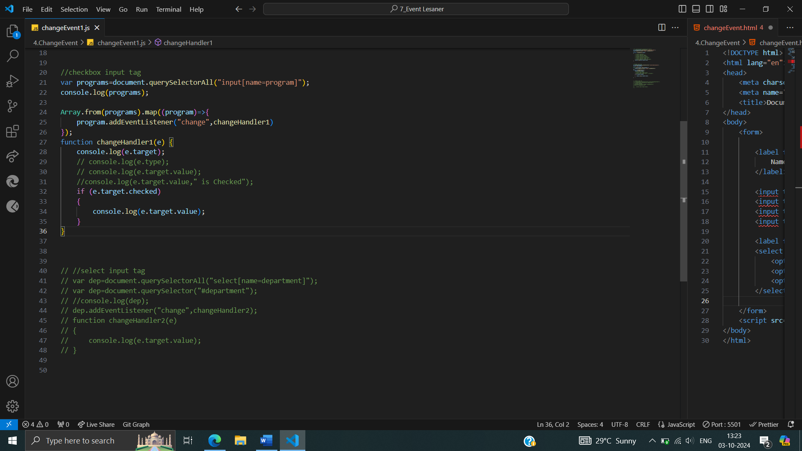

*\*\*****Dynamic Department Selection*** *or* ***Capturing Department Changes in Dropdown***

Captures user interaction with a select input element (dropdown list). When a different option is selected, the changeHandler2 function executes, logging the selected option's value to the console. You can modify changeHandler2 to perform more complex actions based on the user's choice, such as updating other elements, performing calculations, or submitting data to a server.

